--

--
Introduction
This workbook allows you to think through key elements for building
your buyer persona. The more thought you put into this up front, the
more useful your persona will be in the future, so take a few minutes
and really think it through.
You may not know all of the answers - that is okay. Fill in what you
know and then ask your client about the rest. Tel l them you want to
find other clients just like them so you want to know more about
them. They will love it!
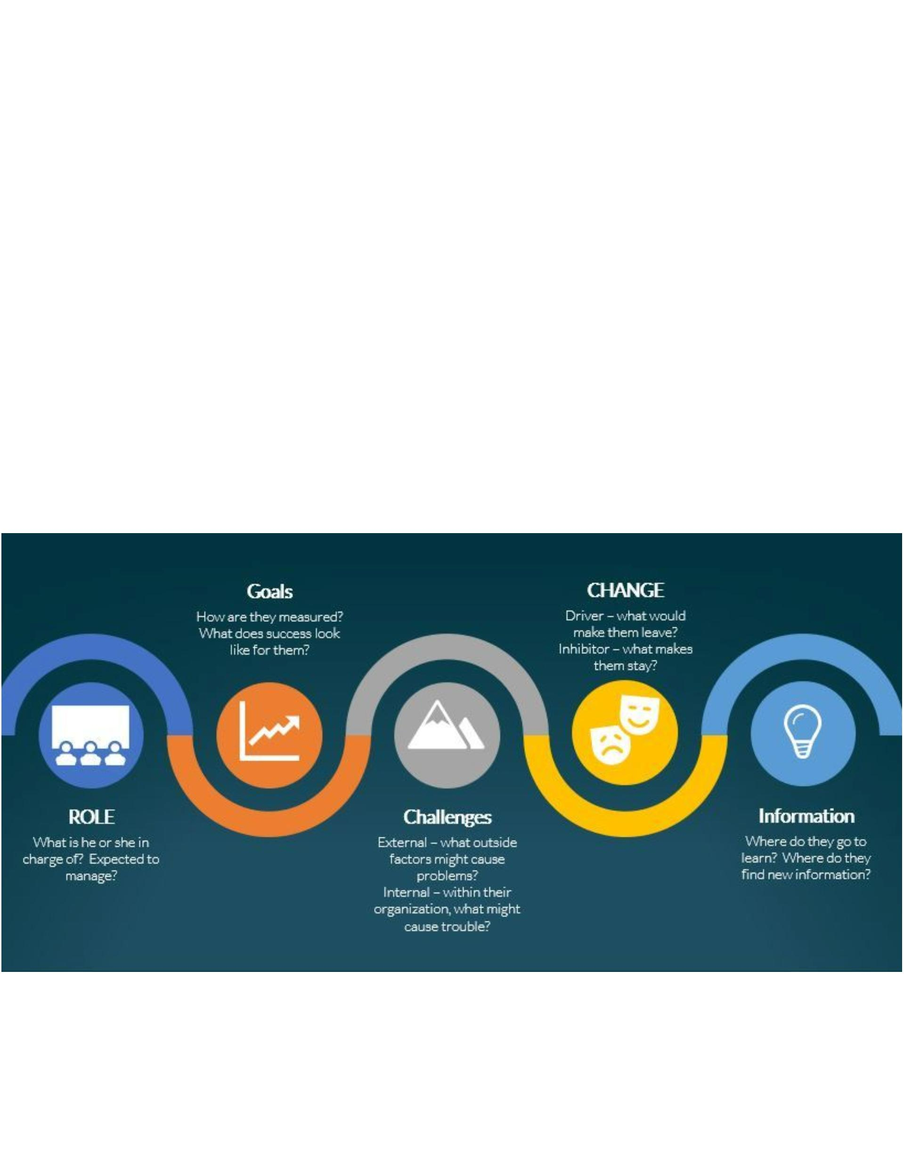

--
Step One
Make a list of some of your best customers for ONE segment. These are the clients you would like
to clone because they are perfect for your specific product. They might be your most profitable
because they always check in on a Sunday night when you are often not full. Or they come during
shoulder seasons. Or maybe they come during peak times but they have a good budget so a
higher ADR isn't out of the question. And they may be different, so try to think of a few clients and
make notes about them in terms of why they are idea.
List a few of your very best customers below. Why are they your best? Make a
note about that too.
Answer here

--
Step Two
Now that you have a few REAL clients in mind, you are going to create
a fictional one. This one will actually be a blend of several of your real
ones. Let's start.
NAME
Let's give your buyer persona a name - to make them feel like a real person. You
can give them a combination of your real client's name or a totally fictional one.
Answer here
TITLE
Now let's give them a title. Take a look at your real customers, do they have any
titles in common? Are the mostly VP Operations? Or Office Managers? They
may not all be exactly the same - in which case you may need to complete a few
of these, but try to find a common title to give your persona that several of your
ideal real clients have.
Answer here

--
Step Three
Now let's take a look at their job - their goals and challenges.
ROLE
Who or what is this person in charge of? Do he/she manage anyone? If so who,
how many?
Answer here
GOAL
How is this person measured? When their boss gives them a performance
review, what things show up? Do they stick to a budget? Do they have to meet
a sales quota? Is technology important? What matters most in their job?
Answer here

--
Step Fo ur
Now let's take a look at their Challenges. Internal and External.
CHALLENGES - INTERNAL
What keeps them up at night? People usually have internal and external
challenges so think about both. An internal challenge might be budget cuts - so
they need to make do with less.
Answer here
CHALLENGES - EXTERNAL
An external challenge might be a new competitor in the market - or several. Go
ahead, list out all of the challenges your persona might have in their job.
Answer here

--
Step Five
Finally now it is all about you.
CHANGE INHIBITORS
What makes those real customers loyal to your hotel? What keeps them coming
back again and again? Is it something about your hotel - or is it you? Or both?
Be specific.
Answer here
CHANGE DRIVERS
What might make them leave you? It is unlikely but what might push them over
the edge to try another property? List as many potential reasons as possible.
Answer here

--
Step Five
This is important. And you may not know the answers.
INFORMATION
Where do they go to get information/trends/help to keep them current in their
job? Remember, this is not ONLY about the part of their job that has them
working with you - but their job in general. If you don't know - ask them. Or go
and look on LinkedIn and see what sorts of groups they belong to, or what they
are liking and reading. Be as specific as possible.
Answer here
That is really all there is to it. You want to keep a copy of this where you can easily
access it because you will need this over and over.
Ideally you will want to create a buyer persona for every one of the segments that you
sell to.

